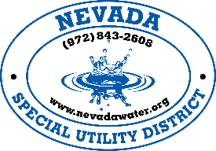

Request for Service Discontinuance

I, ________________________________________ (NSUD Applicant, Co-Applicant as it appears on the original Service Application/Agreement), hereby request that my water service account number ____________located ______________________________________________________ (address of service), be disconnected on _______/_______/_______.

Note: Service will terminate on the date specified above, if the date specified is not a Saturday, Sunday or Holiday and upon the completion of this form.

I understand service will be discontinued on the above date or as soon as possible. I understand that if I should ever require water service reinstated with NSUD, I may have to re-apply for service and may have to pay all costs indicated in a current copy of the NSUD Rate Order. I understand that service may be limited and may require capital improvements to deliver adequate service. I also understand that these improvements will be at my cost. I further represent my co-applicant in this discontinuance request and I am authorized to execute this request on behalf of my co-applicant. I further understand I will be charged for all water usage to the date of disconnection and will be mailed a final bill, upon final reading taken by NSUD.

A final reading will be taken and the meter will be locked. The final water bill and any balance owed previously will be deducted from deposit and remaining balance, if applicable, will be mailed to the forwarding address.

Signature: _________________________________________________Date:____________________
(Must be original applicant or co-applicant on account)

Forwarding Address: _________________________________________________________________

City______________________________State_________________Zipcode______________

108 N Warren Street • Nevada, TX 75173
Phone (972) 843-2608 • Fax (972) 843-2609
Nevadawater.org • nevadawater@nevadawater.org

